™

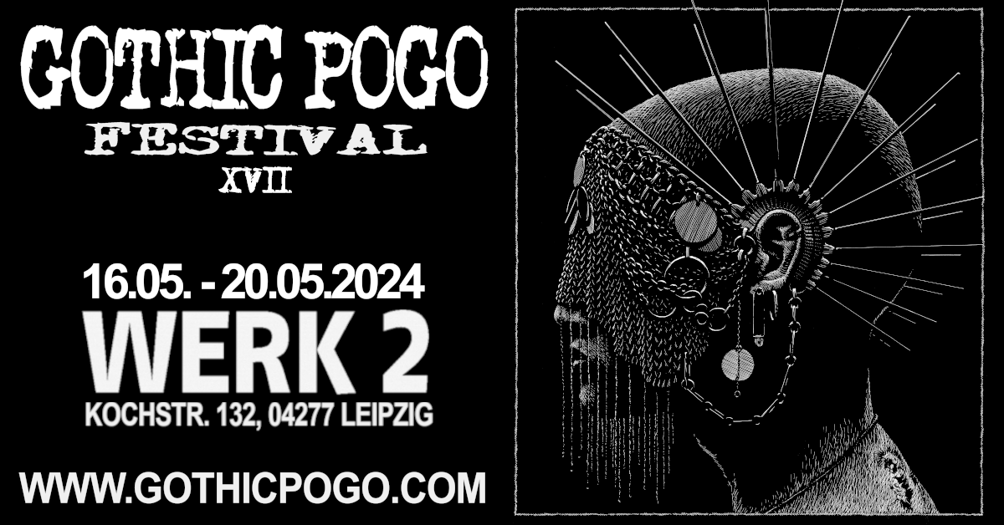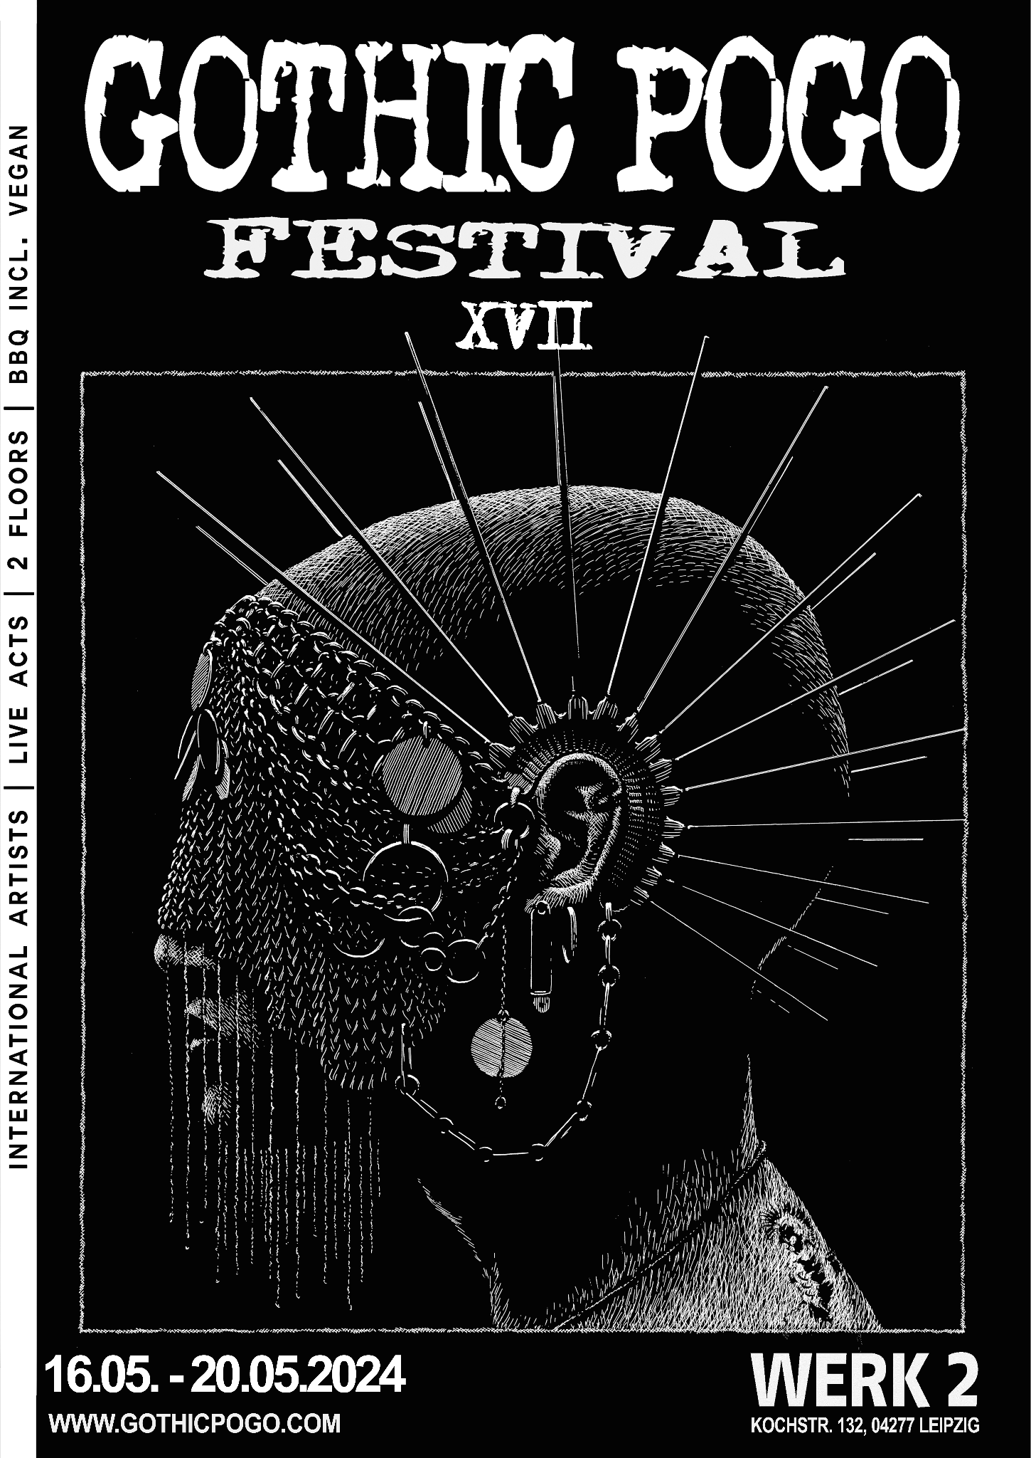

**Gothic Pogo Festival # 17**

The heart of our festival continues to beat strong as we happily invite you to the 17th edition of the Gothic Pogo Festival.

Once again this year, we are celebrating in the tried and tested tradition of bringing DJs and crews from all over the world to our beloved Werk2 venue over five days.

Over four days, we offer a stage for international live bands and performers, from old idols to new sounds of music history, from death rock and postpunk to electro punk and mutant wave. Old and new come together.

Join us again this year to create a safe space in which art and individuality can unfold with respectful cooperation!

By the scene, with the scene, for the scene!

##

Das Herz unseres Festivals schlägt weiter stark, während wir euch voller Freude zur 17. Auflage des Gothic Pogo Festivals einladen.

Auch in diesem Jahr feiern wir in bewährter Tradition und bringen an fünf Tagen DJ*s und Crews aus der ganzen Welt in unsere geliebten Räume des Werk2.

An vier Tagen bieten wir eine Bühne für internationale Live-Bands und Performer*innen, von alten Idolen hin zu neuen Klängen der Musikgeschichte, von DeathRock und Postpunk hinzu Electro Punk und Mutant Wave. Alt und Neu kommt zusammen.

Schafft auch dieses Jahr mit uns gemeinsam den sicheren Raum, in dem sich Kunst und Individualität mit respektvollen Miteinander entfalten kann!

Von der Szene, mit der Szene, für die Szene!

[www.gothicpogo.com](http://www.gothicpogo.com/)

[www.werk-2.de](http://www.werk-2.de/)

Kontakt: info@gothicpogo.com

**Gothic Pogo Festival XVII**

May 16th – 20th 2024

*Deathrock, (Post-, Horror-) Punk, (New-, Minimal-, Cold-) Wave, Obscure 80s*

**---Thursday 16th of May---**

-Halle D / Doors 10pm-

> Unterschall Label Night <

**live on stage**

**NICI** (GER) - Album Release Show!

**Fixed Lens** (GER)  
  
  
Aftershow:

**Post Kontrol** (Hidden Lines, SWE)  
**XO Skeleton** (Unterschall, GER)  
**Maria Maris** (CR)

Live Visuals by: Dean Wallflower

**---Friday 17th of May---**

-Halle D / Doors 9pm-

> Dead & Buried <

**live on stage**

**CIERŃ** (GER)

**Psychoformalina** (PL)

**Lene Lovich Band** (UK)

**Aftershow DJ*s**

**Cavey Nik** (Dead & Buried, GB) **Wrain Havoc** (Dead & Buried, USA) **Hollowed Skies** (Bruits de la Cave, GER) **ZeitUngeist** (Gothic Pogo, GER)

***

-Halle A / Doors 11pm-

(Market open from 9pm)

> Waveteef & Glamour Toujours <

**DJ*s  
Simone la Fontaine** (Glamour Toujours, GER) **Jessi La Palma** (Glamour Toujours, GER) **Mat Zwart** (Waveteef, BG) **LVLVN** (Waveteef, BG)

**---Saturday 18th of May---**

-Halle D / Doors 9pm-

> Mutant Transmissions <

**live on stage**

**Ziguezoy** (JP) **Uphor!a** (IT)

**infantsanchos** (GER)

**Systeme de Eternemiento** (ESP)

**on the decks**

**Polina Y** (Mutant Lab/BG)

**DJ Perikkles** (MEX)  
**Dr Gregor Giesing** (GrGr, GER)

**Industra** (MEX)

**HATE Mior** (CAN)

**CMO** (No!ze Concrete, BG)

***

-Halle A / Doors 11pm-

(Market open from 9pm)

> 10 years: PRESENT OF THE FUTURE<

**DJ*s  
Lottey** (Wavepunk, UndergrouNDW, Post-Punk - Present Of The Future, GER) **Dark Shadow** (Post-Electro/Kraut/Synth/Wave - Claws Of Saurtopia Noisefest, GER) **HURZ!** (Gothrock, Post-Punk, Deathrock - Present Of The Future, GER)

**Surprise Live Act + Performance during the night!**

**---Sunday 19th of May---**

-Halle D / Doors 9pm-

> the legendary Shock Wave marathon<

**live on stage**

**UFO Shadow** (GER)

**Der Mussikant** (GER)

**Techniques Berlin** (CAN)

Aftershow with **M** / **Andre** / **The** **Ringo** (ShockWave/GER)

***

-Halle A / Doors 11pm-

(Market open from 9pm)

> Klub DöD x Return To The Batcave <

**Dini** (Klubb Död, SE) **Nientte** (Klubb Död, SE)  
**Woodraf** (Return to the Batcave, PL)  
**O!**(Return to the Batcave, PL)

**---Monday 20th of May---**

-Halle D / Doors 10pm-

Final Night:

> Reformation Club x Eisengrau <

**Mara Mortem** (Reformation Club, GB) **Fil Noir** (Reformation Club, GB) **Sharleen Voyage** (Eisengrau, GER) **Testbild** (Eisengrau, GER)

**For more information please visit the sites**

[**www.gothicpogo.com**](http://www.gothicpogo.com)

[**www.werk-2.de**](http://www.werk-2.de)

**PreSale starts from 1st of March**

**5-day-ticket = 58,00 EUR plus presale fees**

**Available at: tixforgigs, Reservix**

**If you are interested in vending at the GPFestival, please contact us: info@gothicpogo.com**